# Assignment 01 - ICT 1123 System Analysis Design and Usability

## Group 02

1. Joseph Rasanjana – TG/2019/525
2. Umeen Rathnayake – TG/2019/516
3. Niraj Dilshan – TG/2019/491
4. Waruna Dissanayake – TG/2019/515

# DFD diagrams

## Context diagram

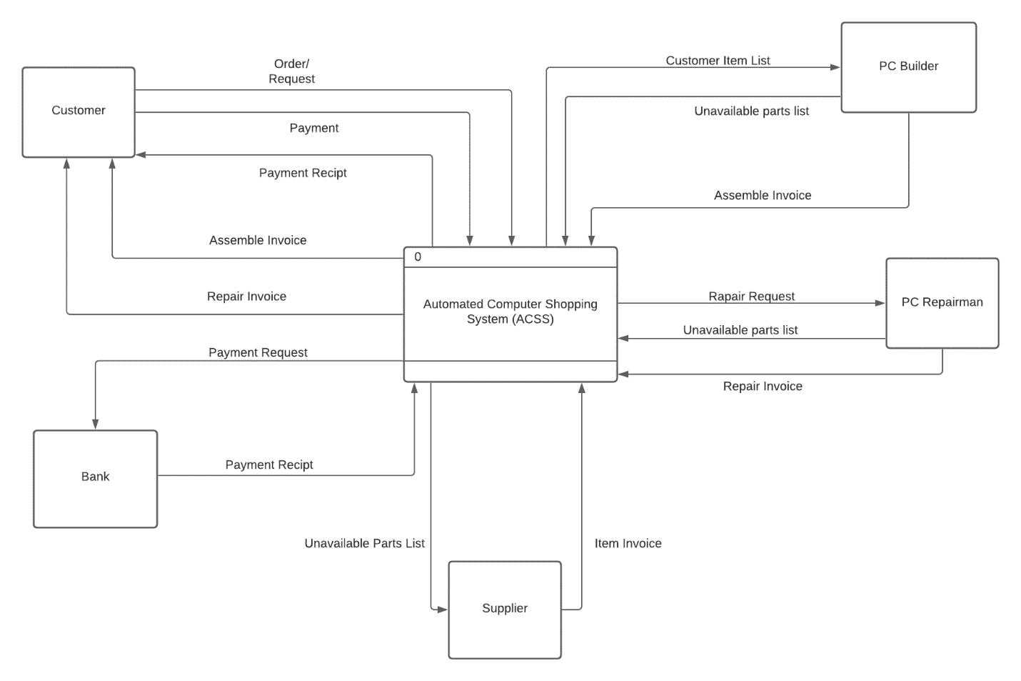

## DFD Level 0

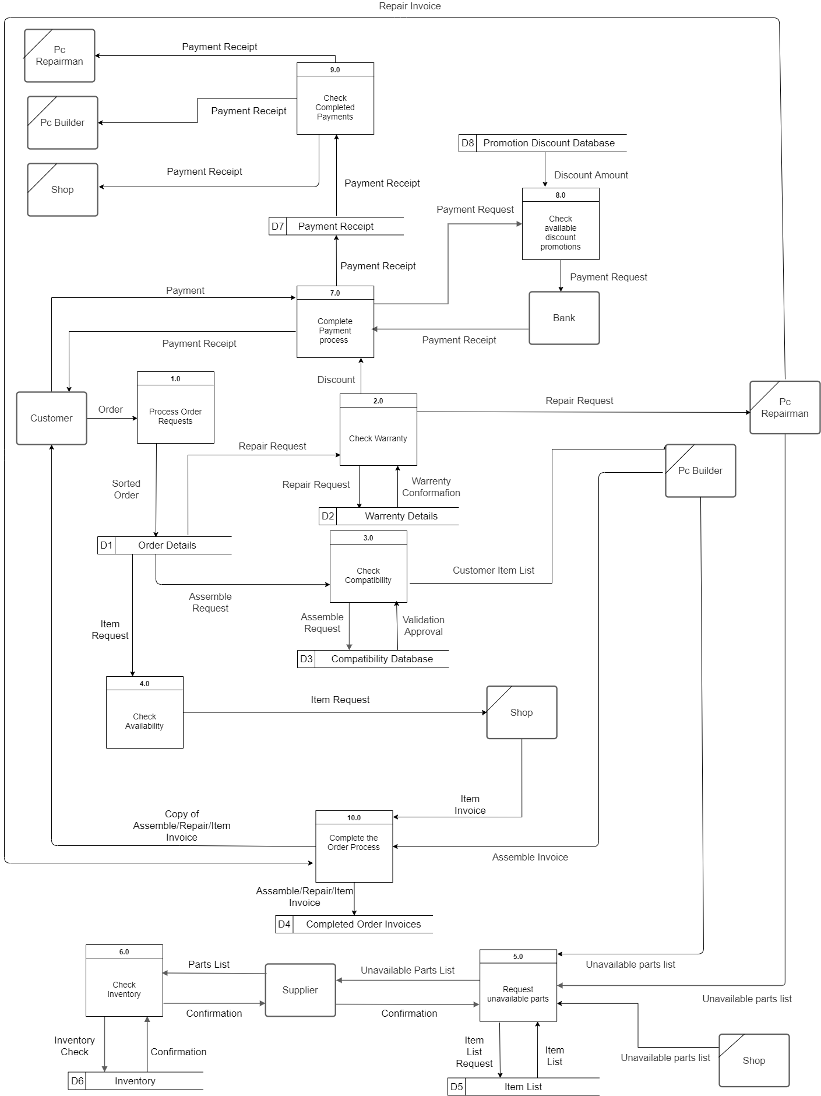

## DFD Level 1

